ELEG 309 - Example Problems Chapter 7-1

**Exercise 7.1**

Consider the amplifier of Fig. 7.2(a) with *VDD* = 1.8 V, *RD* = 17.5 k, and with a MOSFET specified to have *Vt* = 0.4 V, *kn* = 4 mA/V2, and λ = 0. Determine the coordinates of the end points of the active-region segment of the VTC. Also, determine *VDS*|C assuming *VGS*|C = *VDD*.

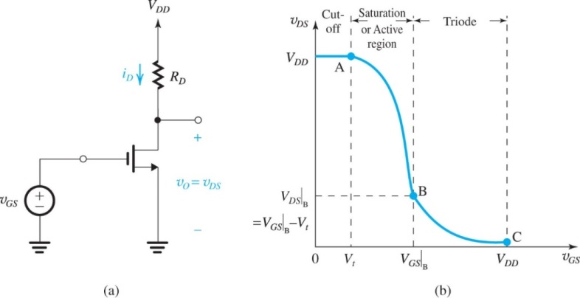



**Example 7.1**

Consider the amplifier circuit shown in Fig. 7.4(a). The transistor is specified to have *Vt* = 0.4 V, *k’n* =0.4 mA/V2, *W*/*L* = 10, and λ = 0. Also, let *VDD* = 1.8 V, *RD* = 17.5 k, and *VGS* = 0.6 V.

(a) For *vgs* = 0 (and hence *vds* = 0), find *VOV*, *ID*, *VDS*, and *Av*.

(b) What is the maximum symmetrical signal swing allowed at the drain? Hence, find the maximum allowable amplitude of a sinusoidal *vgs*.

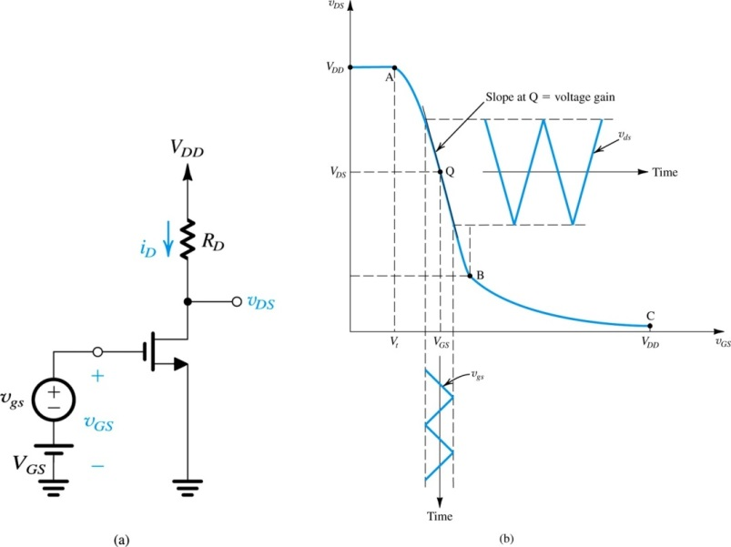

**Example 7.2**

Consider an amplifier circuit using a BJT having *IS* = 10−15 A, a collector resistance *RC* = 6.8 k, and a power supply *VCC* = 10 V.

(a) Determine the value of the bias voltage *VBE* required to operate the transistor at *VCE* = 3.2 V. What is the corresponding value of *IC*?

(b) Find the voltage gain *Av* at this bias point. If an input sine-wave signal of 5-mV peak amplitude is superimposed on *VBE*, find the amplitude of the output sine-wave signal (assume linear operation).

(c) Find the positive increment in *vBE* (above *VBE*) that drives the transistor to the edge of saturation, where *vCE* = 0.3 V.

(d) Find the negative increment in *vBE* that drives the transistor to within 1% of cutoff (i.e., to *vCE* = 0.99 *VCC*).

